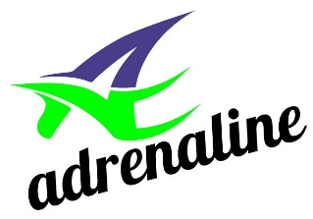

Competitive Team Video Try-outs

- We are looking for kids that are full of energy, strong minded/strong willed, perseverant, tough and fearless! Kids who absolutely enjoy physical activity, and who display some or all of these qualities: Speed strength, flexibility, and coordination!

- Those athletes who have previous dance experience who are showing an interest in the acrobatic component of gymnastics, are also invited to email over their submissions.
Submissions should include:
- skipping, chin-ups, leg lifts or leg raises, push-ups and sit-ups.
- They should also include demonstrations of flexibility. (ie. splits all ways, and bridges)
- Submissions can include any prior gymnastics or acrobatic skills the athlete can do safely at home.
- Finally, the submission should show body alignment! (Have the athlete both on their stomach and back with their arms straight above their head, laying as flat on the floor as they can).
- The athletes should be wearing a gymsuit/leotard/bathing suit/dance leotard (minus the skirt portion), tight or in the case that you don't own any of those, a tight fitting t-shirt and shorts.
- We are primarily looking for =girls born in 2010-2016.

All virtual tryout video presentations can be sent directly to Craig Smith at Headcoachagtcwag@gmail.com.

Craig Smith
Women's Head Coach
Adrenaline Gymnastics and Training Centre
177 Zenway Blvd, #3
Vaughan, ON L4H 3H9
905 850 8606
Email: headcoachagtcwag@gmail.com
Website: www.agtc.ca

